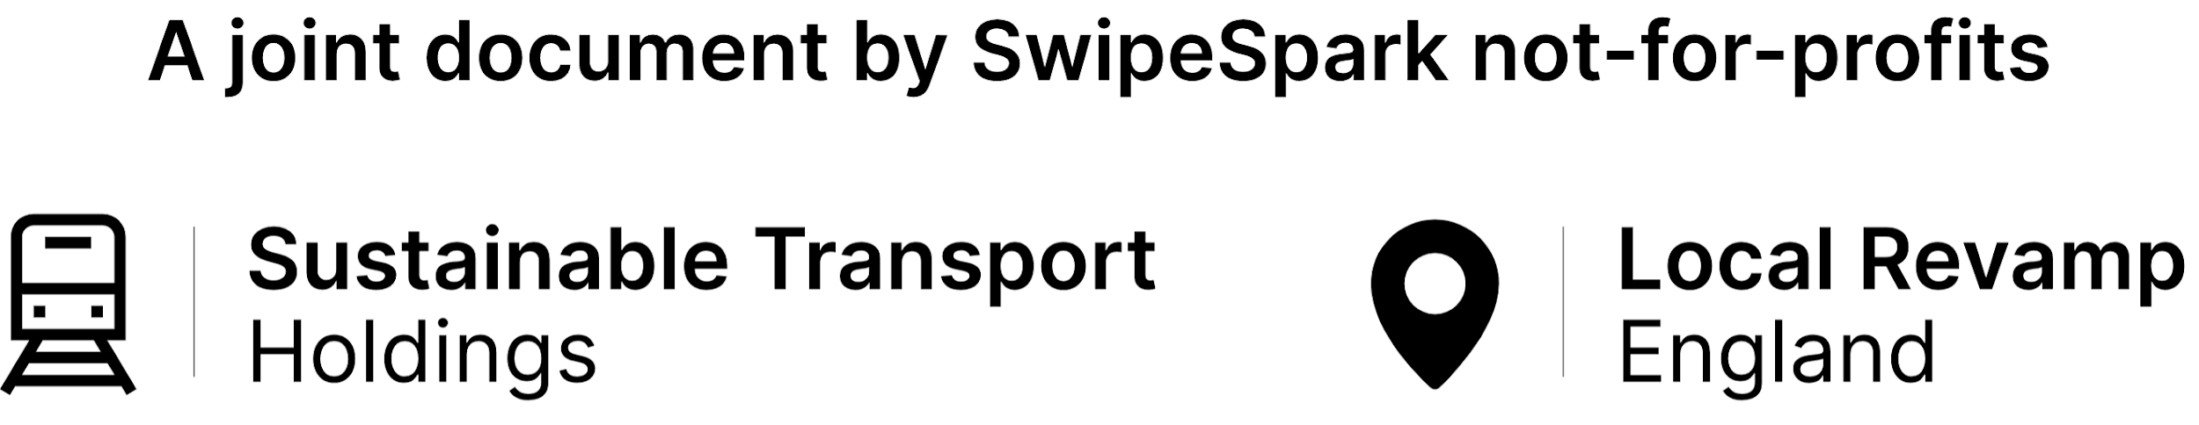

**Volunteering to scale up**

**Last review date:** December 22nd, 2020 (*published*)

**Next review due:** June 22nd, 2021

**Notes:** This document is mainly based around Sustainable Transport Holdings, not

Local Revamp England.

**Contents**

1. What we mean by scaling up
   1. Being future-proof
   2. Success in our campaigns
   3. More demand for us locally
   4. Success in being known
2. Positives of volunteering
   1. Less work for one person
   2. More expertise
   3. Local volunteers bringing local knowledge
   4. Less stress
3. Open positives proposed
   1. Sustainable Transport Holdings
      1. Location based
      2. Role based
   2. Local Revamp England
      1. Location based
      2. Role based

1. **What we mean by scaling up**
   1. Being future-proof
      1. Being available to handle popularity in the future, as more of our campaigns succeed, and as more of the local population learn about us and find out about us.
      2. As time continues, it is also obvious our public transport and local council situation can only improve, so we need to be future-proof to be able to handle improvements to the services we are campaigning for.
   2. Success in our campaigns
      1. As our campaigns become more successful, more funded, and approved by Central Government, people will find out about us, meaning we will be a lot busier.
      2. To accept this demand, we need more people to help us, in the case of being approved, in places such as PR
   3. More demand for us locally
      1. As more people hear of our campaigns locally, more local people and businesses will get in touch, probably either asking when it will be done, or can you do this, can you do that etc.
      2. One person cannot manage all these requests, which is why we need to start bringing more people on to help us.
   4. Success in being known
      1. As more people learn about us, either during success in our campaigns, or word of mouth, social media etc, more people from places such as the local press, local businesses, and local councils, will more than likely get in touch.
      2. We need a dedicated team to manage these contact requests, which is why volunteers might make sense.
2. **Positives of volunteering**
   1. Less work for one person
      1. Now, most of our work is completed by one person, who also has school, other projects, and revision to be completed. As the projects grow, the demand for priority for Harry on these not-for-profits continues to grow with it, taking away time from his schoolwork, and revision, which is, now, more important.
   2. More expertise
      1. Not only this, but more expertise would be gained by more people joining the team, especially with specialised roles such as Bus Correspondent. For example, Harry does not know much about the bus timetabling system. Someone else joining us could help us campaign more for better bus routes instead of relying on someone who knows less about it.
   3. Local volunteers bringing local knowledge
      1. It is not only knowledge on a national scale on specific topics, but also on a local level, allowing people in small villages and towns to give us insight locally as to what the people living there really want, instead of us in Northampton just having to guess what people in, for example, Burton upon Trent, want.
   4. Less stress
      1. Now, one person is working on everything, and with so much other stuff going on in their life, some things are just too much to handle. Accepting volunteers will take some stress off Harry, and give him time to work on other things, and prioritise what needs to be prioritised.